SESSION 2015

SELECTION INTERNATIONALE
ECOLE NORMALE SUPERIEURE

Sujets Discipline secondaire
Biologie

Durée : 1h30

This exam is composed of nine independent questions and one problem.

Answer the following questions. Drawings and schemes are allowed.

Question 1: What is a fusion protein?
Question 2: How do people use fusion proteins in order to tag proteins in living cells?

Figure 1: E. coli as a standard ruler for characterizing spatial scales.

Question 3: Use figure 1 to justify the assumption that a typical bacterial cell (that is, E. coli) has a surface area of 6µm² and a volume of 1µm³. Make a corresponding estimate of the mass of such a bacterium.
Question 4: Roughly 2-3kg of bacteria are harbored in your large intestine. Make an estimate of the total number of bacteria inhabiting your intestine. Estimate the total number of human cells and compare the two figures.
Question 5: What is the cytoskeleton and what are the main components?
Question 6: what are the different roles of the cytoskeleton? Please structure your answer.
Question 7: describe the main steps of protein synthesis in eukaryotic cells (20 lines max + potential drawings)
Question 8: What is the resting potential of a neuron? What are the physics behind and the general law that allows its computation?
Question 9: What is an action potential for a neuron?
Problem

In 2002, Elowitz et al. designed and constructed a new synthetic network to implement a particular function. They used three transcriptional repressor systems that are not part of any natural biological clock to build an oscillating network, termed the repressilator, in Escherichia coli. In the network shown in Fig. 1a, the first repressor protein, LacI from E. coli, inhibits the transcription of the second repressor gene, tetR from the tetracycline resistance transposon Tn10, whose protein product in turn inhibits the expression of a third gene, cI from l phage. Finally, CI inhibits lacI expression, completing the cycle. They used a reporter gene coding for a green fluorescent protein (GFP) to visualize the behavior of the repressilator system. The results are presented in figure 2.

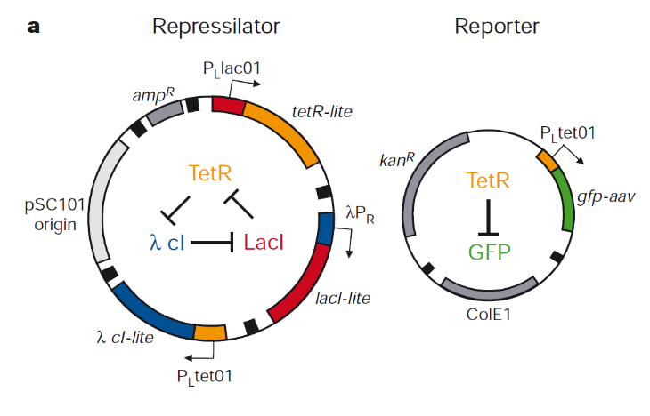
Figure 1a: genetic scheme of repressilator system

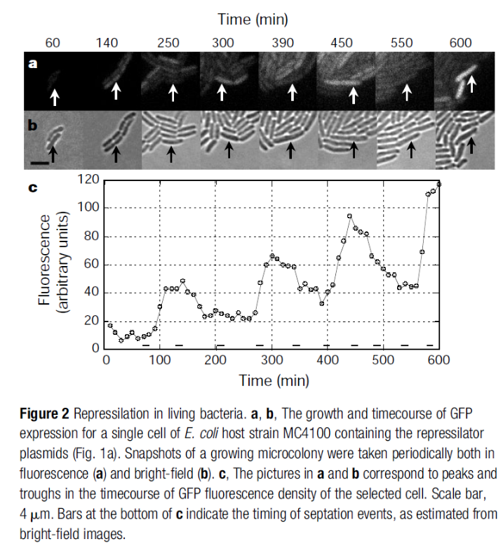

Explain the oscillatory behavior of the repressilator presented in figure2, and propose a mathematical model that could depict the behavior of the repressilator.

